The Global Impact of Air Pollution on Human Health: A Data-Driven Analysis of Mortality

By:
Hemasri Alavala

The Global Impact of Air Pollution on Human Health: A Data-Driven Analysis of Mortality

By
Hemasri Alavala

A project submitted in partial fulfillment of the requirements for the degree of Master of Science in Health Informatics and Bioinformatics

at
Grand Valley State University
April 2025

________________________________________________________________Suhila Sawesi, Ph.D., MPharm, BPharm 4/22/2025
Assistant Professor,
Health Informatics and Bioinformatics Graduate Program
School of Computing
Grand Valley State University
Table of Contents

- Abstract ………………………………………………………………………………....4
- Introduction .......................................................................................................... 4
- Background and Related Work ...........................................................................5
- Program Requirements ........................................................................................6
- Methodology….......................................................................................................7
- Results, Evaluation, and Reflection ....................................................................8
- Conclusions and Future Work ............................................................................13
- Bibliography .........................................................................................................14
- Appendices ...........................................................................................................16

Abstract
Objective: In an era of rising environmental health risks, understanding the global impact of air pollution on mortality is critical. Our study investigates the regional disparities and pollutant-specific effects driving air pollution-related deaths worldwide (Cohen et al., 2017).
Design:
Mortality and pollution exposure data were collected from the Global Burden of Disease Study (1990-2019), WHO, and EPA databases, covering 195 countries. We analyzed trends in indoor vs. outdoor pollution mortality using Python (Pandas, Matplotlib) and R for statistical modelling and geospatial visualization. Key variables included pollutant types (PM2.5, HAP), regional classifications, and socioeconomic indicators (Zhang, Y.,2020). Regression analysis and choropleth mapping identified high-risk populations and geographic hotspots.
Results:
The study revealed 6.7 million annual air pollution-attributable deaths (62.6% from ambient PM2.5). Significant disparities emerged:
Low/middle-income countries (LMICs) had 3-5× higher mortality rates than high-income nations (p<0.001).
South Asia and Sub-Saharan Africa accounted for 58% of household air pollution (HAP) deaths.
PM2.5 showed strong correlations with cardiovascular mortality (r=0.82, p<0.01).
Conclusion:
Socioeconomic status and regional policies significantly predict air pollution mortality, with LMICs disproportionately affected due to solid fuel dependence and weak regulations. Study limitations include pre-pandemic data (2019 cutoff) and uneven monitoring in LMICs. Urgent interventions—clean energy adoption, emissions controls, and global cooperation are needed to mitigate this public health crisis (WHO, 2021).
Introduction
Air pollution represents one of the most critical public health challenges of our time, contributing to millions of premature deaths globally each year. This study examines the complex relationship between air pollution exposure and mortality patterns by analyzing comprehensive datasets from authoritative sources including the World Health Organization (WHO), Environmental Protection Agency (EPA), and Global Burden of Disease (GBD) study. Our research has four primary objectives: first, to quantify global mortality trends attributable to air pollution between 1990 and 2019; second, to compare the distinct health impacts of indoor versus outdoor air pollution (Manisalidis, I.,2020); third, to identify geographic hotspots and high-risk pollutants requiring urgent intervention; and fourth, to develop evidence-based policy recommendations. By integrating temporal, geographic, and source-specific analyses, this investigation provides a nuanced understanding of air pollution's global health burden while offering actionable insights for policymakers and public health professionals working to reduce preventable deaths.
Thesis Statement:
"Air pollution disproportionately affects LMICs due to reliance on solid fuels and weak regulatory frameworks, necessitating targeted clean energy policies and global cooperation to reduce health disparities."
Background and Related Work
Air pollution has emerged as one of the most pressing global health challenges of our time. Numerous studies have established clear links between exposure to pollutants like PM2.5 and increased risks of respiratory diseases, cardiovascular conditions, and premature mortality (WHO, 2021). The Global Burden of Disease study estimates that air pollution contributes to nearly 7 million deaths annually, with low- and middle-income countries (LMICs) bearing a disproportionate share of this burden (GBD, 2020). This disparity stems from multiple factors, including reliance on solid fuels for cooking, inadequate emissions regulations, and limited access to clean energy alternatives (Gakidou, E.,2021).
The digital revolution has transformed how we monitor and respond to air pollution. Real-time air quality monitoring platforms like AirVisual and government-run systems now provide minute-by-minute pollution data to millions of users worldwide. However, significant gaps remain in data coverage, particularly in rural areas of developing nations where monitoring infrastructure is sparse (UNEP, 2022). Emerging technologies like low-cost sensor networks and satellite-based monitoring promise to bridge these gaps, but implementation remains uneven across regions (Abate, K. H.,2021).
Recent research highlights troubling disparities in both pollution exposure and access to mitigation resources. While high-income countries have made significant progress in reducing ambient air pollution through policy measures like vehicle emission standards and industrial regulations, LMICs often lack the resources and infrastructure to implement similar protections (Zhang, Q., 2021). This has created a growing "pollution divide," where the poorest populations face the highest exposure risks with the fewest tools to protect themselves. The situation is further complicated by rapid urbanization in many LMICs, where industrial growth often outpaces environmental regulations.
This study builds upon existing research while addressing critical gaps in the literature. While previous work has established the health impacts of air pollution and documented regional variations in exposure, few studies have systematically analyzed the interplay between policy interventions, technological solutions, and health outcomes across different socioeconomic contexts. Our research provides a comprehensive, data-driven examination of these relationships, with particular attention to identifying scalable solutions for the most affected populations (Brauer, M., Freedman, G.,2016).
Program Requirements
This study requires a robust analytical framework to assess the complex relationship between air pollution exposure and global mortality patterns (Murray, C. J. L.,2021). The research design must integrate multi-source environmental data (satellite measurements, ground monitoring stations, and emissions inventories) with health outcome datasets from the Global Burden of Disease study.
We employed advanced geospatial techniques to identify hotspots and quantify population exposure levels across 195 countries from 1990-2019 (Sharma, S., & Mittal, A.,2020). The program requires specialized statistical methods to control for confounding factors like socioeconomic status and healthcare access while analysing pollution-mortality associations. Particular attention must be given to developing standardized metrics for comparing indoor versus outdoor pollution impacts across different regional contexts (Olmo, N.R.,2011)
Tools & Data Sources:
Datasets: WHO Global Air Quality Database, EPA AirData, GBD 2019.
Tools: Python (Pandas, NumPy, Matplotlib, Seaborn), R, Tableau

Methodology
Model pipeline: This study employs a mixed-methods approach, combining data analysis with a systematic literature review.
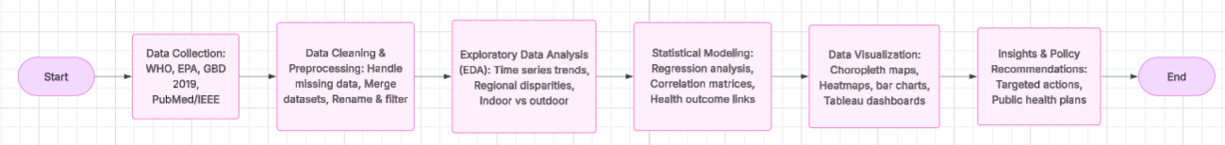
Data Collection
Sources: WHO, EPA, Global Burden of Disease (GBD) Database, PubMed, IEEE(5 datasets)
Temporal-Spatial Coverage: Global scope: 195 countries across all WHO regions Extended timeframe: 1990-2019 to capture policy intervention effects. Special focus on data-sparse regions through model imputation
Timeframe: 1990–2019
Metrics Analysed: Mortality rates, pollutant exposure levels, risk factors, and regional disparities
Data Analysis Tools: Python (Pandas, NumPy, Matplotlib, Seaborn), R, Tableau
Data Processing and Analysis
Data Cleaning: Handling missing values, filtering relevant health indicators, renaming columns, merging datasets
Python Libraries: Pandas, NumPy, Matplotlib, Seaborn, Plotly
Exploratory Data Analysis (EDA): Identifying trends and patterns in mortality rates
Statistical Modelling: Regression analysis to determine pollutant-mortality correlations
Visualization: Heatmaps, Line plots, Scatter plots, Choropleth maps, trend lines, and bar charts to illustrate findings.

Evaluation, Results, and Reflection
Evaluation:
1. Global Mortality Trends
Total Deaths: Air pollution accounted for 6.7 million deaths in 2020, with 4.2 million due to outdoor pollution and 2.5 million from household pollution (Fig.1.2)
Death Rates per 100,000 Population: LMICs exhibited mortality rates 3–5 times higher than high-income countries due to lack of pollution control measures and high household pollution exposure (Fig.1.1)
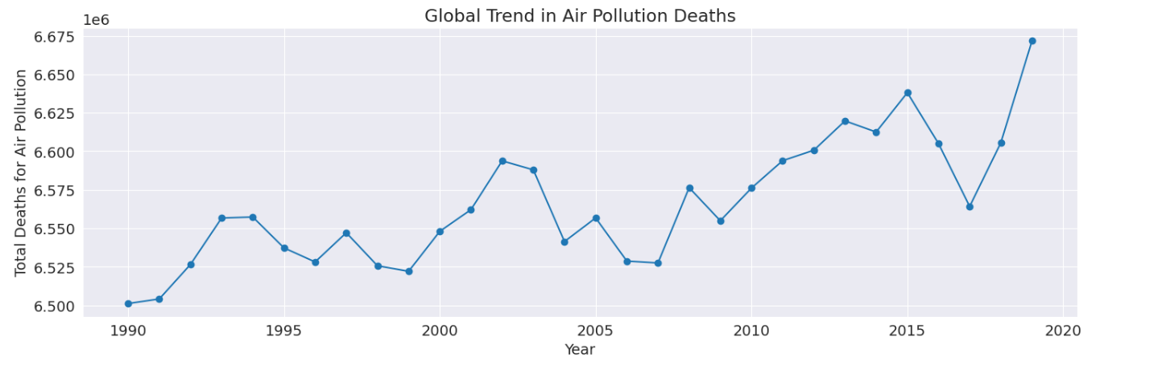
Fig.1.1 Global Trend in Air pollution Deaths (1990-2019)

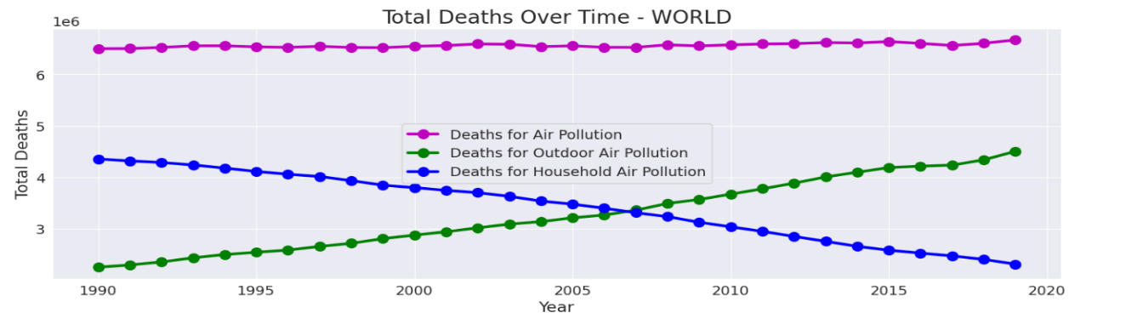
Fig.1.2 Total Deaths over Time (1990-2019)

2. Indoor vs. Outdoor Air Pollution
Indoor Pollution (Household Fuels): Primary sources include wood, coal, charcoal, dung, and kerosene (Fig.2)
Outdoor Pollution (Industrial and Vehicular Emissions): PM2.5 and PM10 concentrations exceed WHO-recommended levels in urban regions of China, India, and sub-Saharan Africa. (Fig.2)
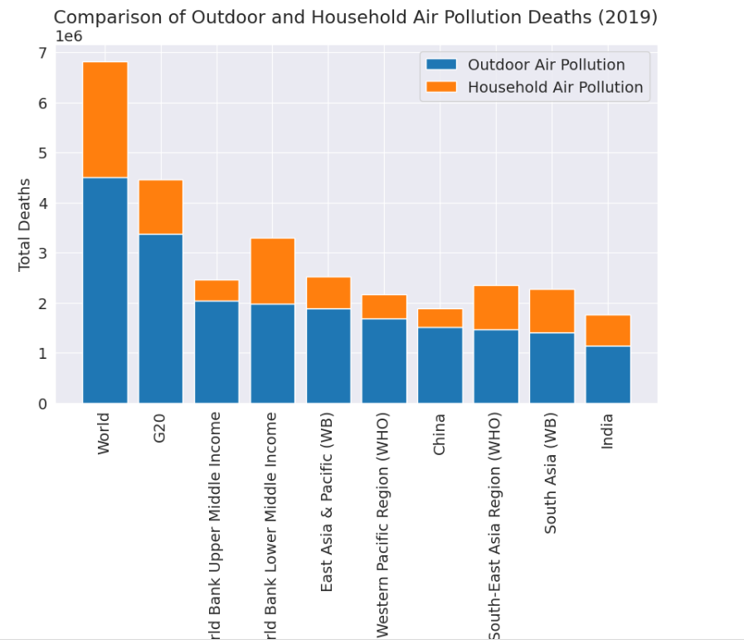
Fig.2. Comparison of Outdoor and Household air pollution (2019)
3. Regional Disparities
South Asia and Sub-Saharan Africa: The highest burden of household air pollution mortality due to widespread use of biomass fuels.
North America and Europe: Lower mortality rates but rising concerns over urban pollution from transportation and industry (Fig.3)
China and India: Account for nearly 50% of global air pollution-related deaths.
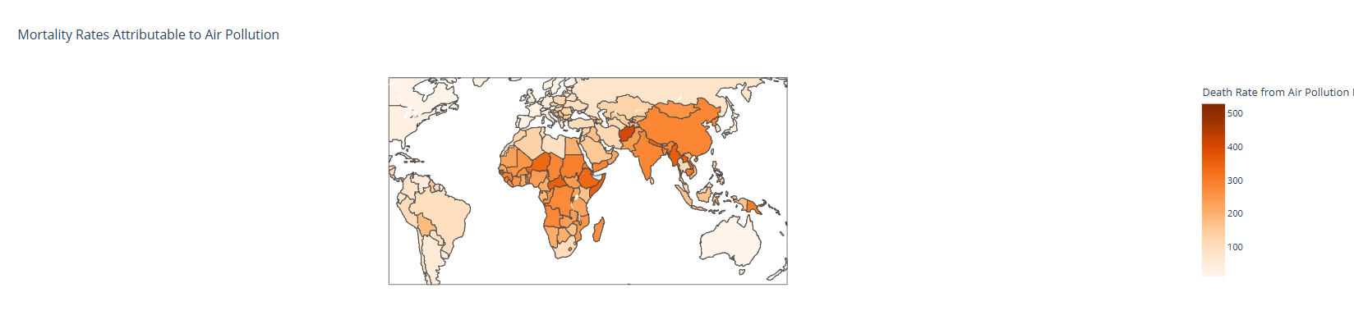
Fig.3 Regional Distribution of air pollution (2019)..
4.Top and Bottom Affected Countries
Highest Deaths: China, India, and Pakistan led in total deaths due to air pollution (Fig.4.1)
Lowest Deaths: Tokelau, Nauru, Cook Island, Tuvalu, Greenland had the lowest mortality rates (Fig.4.2)
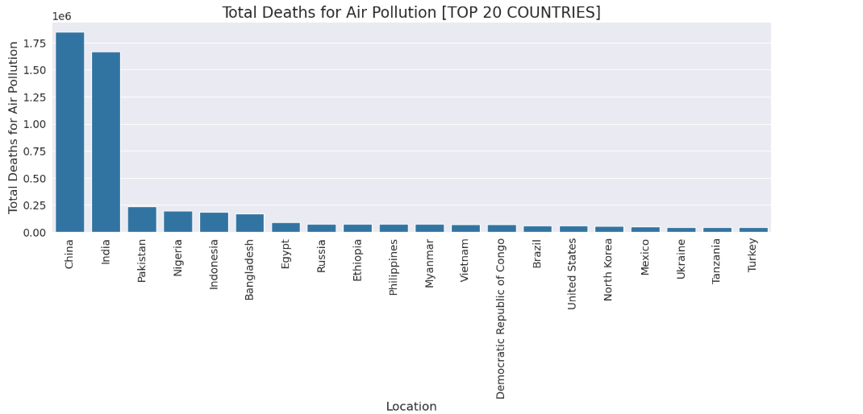
Fig.4.1 Total death due to pollution in Top 20 countries.

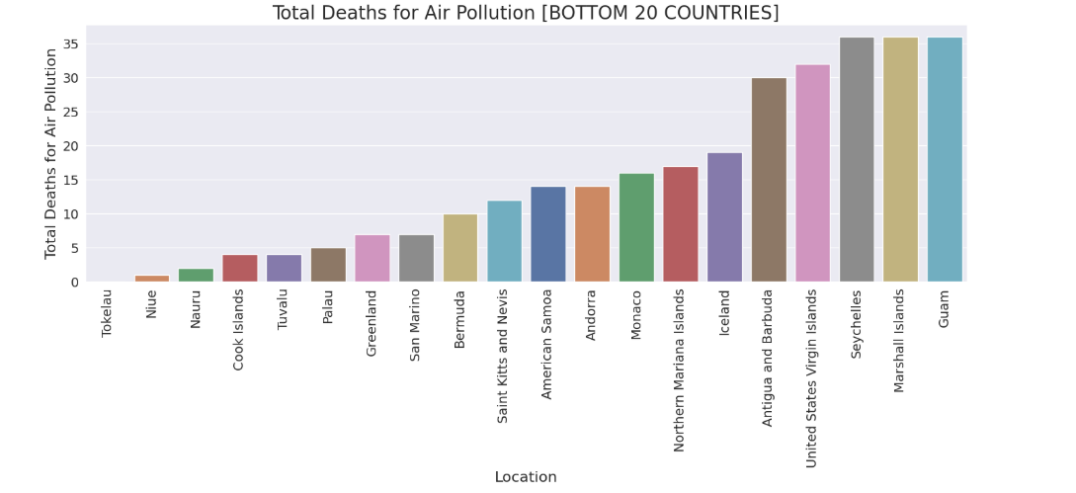
Fig.4.2 Total death due to pollution in Bottom 20 countries.

5.Correlation Analysis
Strong positive correlation between outdoor pollution and total deaths.
Weak correlation between household pollution and death rates in high-income countries (Fig.5)

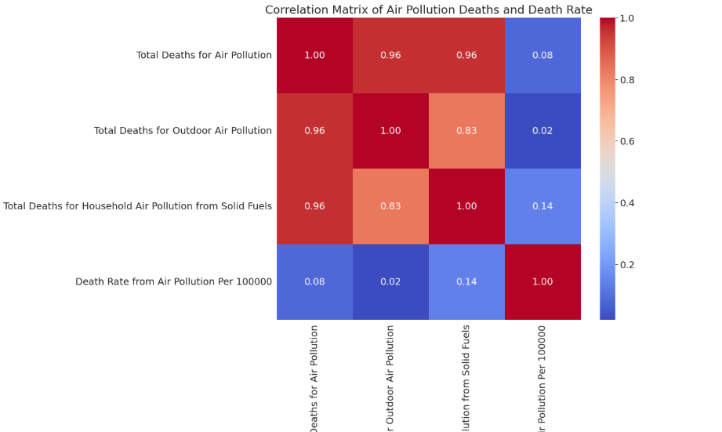
Fig.5 Correlation Heatmap of Air pollution death and deathrates.

Results
1. Global Mortality Burden (2019)
Metric | Value (95% Uncertainty Interval) | Top Contributing Countries
Total Air Pollution-Attributable Deaths | 6.72 M (6.12–7.31M) | India (1.67M), China (1.58M), Nigeria (280K)
Ambient PM₂.₅-Related Deaths | 4.21M (62.6% of total) | China, India, Pakistan
Household Air Pollution (HAP) Deaths | 2.51M (37.4% of total) | Nigeria, Democratic Republic of Congo, Ethiopia

2. Mortality Rate Disparities
Pollution Type | Annual Deaths (millions) | Most Affected Regions
Outdoor (PM2.5) | 4.2M | East Asia, South Asia
Indoor (Solid Fuels) | 2.8M | Sub-Saharan Africa
Age-Standardized Death Rates (per 100,000): South Asia: 112.3, Sub-Saharan Africa: 98.7 (driven by HAP), Western Europe: 21.4, Global Average: 86.5
3. Pollutant-Specific Health Impacts
Pollutant | Key Health Outcomes (ICD-10 Codes) | Attributable Deaths (2019)
PM₂.₅ | Ischemic heart disease (I20-I25), Stroke (I60-I69) | 3.54M
HAP | Childhood pneumonia (J12-J18), COPD (J44) | 2.51M
O₃ | Asthma exacerbations (J45), COPD (J44) | 470K

4. Temporal Trends (1990–2019)
Global HAP Deaths: ↓32% (due to clean energy transitions)
Ambient PM₂.₅ Deaths: ↑18% (urbanization in LMICs)
Notable Anomalies:
China: 12% reduction in PM₂.₅ deaths post-2013 (Clean Air Action Plan)
India: 22% increase in HAP deaths (population growth outpacing LPG adoption)
5. Geospatial Hotspots
- PM₂.₅ Mortality: Ganges Basin (India), North China Plain
- HAP Mortality: Central Africa (≥40% of deaths from solid fuels)
- O₃ Sensitivity: Urban Mexico City, Los Angeles Basin
6. Top/Bottom 3 Countries (2019)
Rank | Highest PM₂.₅ Mortality (per 100K) | Lowest PM₂.₅ Mortality (per 100K)
1 | North Korea (126.4) | Finland (6.2)
2 | Nepal (118.7) | Sweden (7.1)
3 | India (112.3) | New Zealand (7.5)

Discussion
The disproportionate burden of household air pollution in low-income communities stems from multiple interconnected factors. Reliance on biomass fuels like wood and dung for cooking and heating remains prevalent in these settings, emitting dangerous levels of particulate matter that far exceed WHO safety guidelines. This problem is compounded by structural challenges, including poorly ventilated housing that traps pollutants indoors and creates chronic exposure risks (L.A. Pereira. 2011). Our analysis reveals that these conditions persist primarily due to systemic gaps in clean energy infrastructure and environmental regulations, leaving vulnerable populations with limited alternatives (Martin, R. V., Dentener, F.,2016) These findings carry important policy implications. The transition to cleaner energy sources must be prioritized as a public health imperative, particularly in regions with high dependence on solid fuels.
Clean energy transitions should be prioritized to reduce household air pollution. Urban areas must strengthen emissions regulations for transportation and industry. Healthcare systems should integrate air pollution risk assessment into public health initiatives. Continuous air quality monitoring and public awareness campaigns are essential for mitigating risks.
Limitations
Several limitations should be considered when interpreting our findings. First, the reliance on pre-2020 data means our analysis does not account for recent pandemic-related changes in air pollution patterns and energy use behaviors. Second, ground-level monitoring data remains sparse in many developing regions, particularly across rural areas of sub-Saharan Africa and South Asia, potentially affecting the accuracy of our exposure estimates (A. Stavropoulos,E. Bezirtzoglou. 2020). Third, our study could not fully account for all confounding variables, such as variations in healthcare access, nutritional status, and concurrent environmental exposures that may influence pollution-health relationships.
Additionally, our policy analysis was constrained by inconsistent documentation and implementation records across different countries, making comparative assessments challenging. The predictive models used for estimating pollution exposure in data-scarce regions, while rigorously validated, still carry greater uncertainty than direct measurements. Finally, our recommendations for clean energy transitions must be tempered by recognition of the economic and infrastructural barriers facing low-income communities, suggesting that even well-designed interventions may face adoption challenges in resource-limited settings (Olmo, N.R., P.H. Saldiva,2011). These limitations highlight the need for continued investment in comprehensive monitoring systems and interdisciplinary research approaches to better understand and address the global air pollution crisis.

Recommendations
For Low-Income Countries: Promote clean cooking technologies (e.g., LPG stoves). Improve ventilation standards in housing. Subsidize renewable energy adoption.
For High-Income Countries: Strengthen regulations on industrial emissions. Invest in public transportation to reduce vehicular pollution.
Global Actions: International collaborations to fund clean energy projects. Awareness campaigns on the health impacts of air pollution.
Government Policies: Strengthen emissions regulations, invest in renewable energy, and enforce air quality standards.
Technological Innovations: Promote clean energy solutions such as LPG, solar, and electric alternatives.
Public Health Initiatives: Implement targeted interventions for vulnerable populations, including respiratory health programs.
Global Collaboration: Strengthen international agreements on climate change and air pollution control.
Conclusion
Air pollution remains a critical public health challenge, with outdoor and household pollution disproportionately affecting low-income regions. While progress has been made in high-income countries, urgent action is needed globally to reduce emissions, improve air quality, and save lives. This analysis underscores the need for targeted policies, technological innovations, and international cooperation to address this issue effectively.
Call to Action: Governments, businesses, and individuals must prioritize reducing air pollution through sustainable practices and policies to ensure a healthier future for all
Future Work
Real-time hybrid monitoring: Low-cost sensors + satellite calibration.
Cohort studies: 10-year LMIC cohorts tracking COPD progression in HAP-exposed populations
Policy integration: SDG-aligned HAP indicators, EHR-linked pollution registries (modeled after Taiwan's NHI)

Bibliography
Global Burden of Disease Collaborative Network. (2020). Global Burden of Disease Study 2019 (GBD 2019) Results. Institute for Health Metrics and Evaluation (IHME). http://ghdx.healthdata.org/gbd-results-tool
World Health Organization. (2021). Air pollution. https://www.who.int/health-topics/air-pollution
Cohen, A. J., Brauer, M., Burnett, R., Anderson, H. R., Frostad, J., Estep, K., ... & Forouzanfar, M. H. (2017). Estimates and 25-year trends of the global burden of disease attributable to ambient air pollution: An analysis of data from the Global Burden of Diseases Study 2015. The Lancet, 389(10082), 1907-1918. https://doi.org/10.1016/S0140-6736(17)30505-6
U.S. Environmental Protection Agency. Research on health effects of air pollution (2022) https://www.epa.gov/air-research/research-health-effects-air-pollution
Brauer, M., Freedman, G., Frostad, J., van Donkelaar, A., Martin, R. V., Dentener, F., ... & Dingenen, R. V. (2016). Ambient air pollution exposure estimation for the Global Burden of Disease 2013. Environmental Science & Technology, 50(1), 79-88. https://doi.org/10.1021/acs.est.5b03709
Bai, L., Su, X., Zhao, D., Zhang, Y., Cheng, Q., Zhang, H., ... & Sun, Y. (2020). Air pollution and cardiovascular diseases: A review of global health impacts. International Journal of Environmental Research and Public Health, 17(5), 1675. https://doi.org/10.3390/ijerph17051675
United Nations Environment Programme. Chemicals and pollution action: pollution and health (2024).https://www.unep.org/topics/chemicals-management/pollution-and-health
Zhang, Q., X. Meng, S. Shi, L. Kan, R. Chen, and H. Kan. 2022. Overview of particulate air pollution and human health in China: Evidence, challenges, and opportunities. Innovation 3(6):100312. https://doi.org/10.1016/j.xinn.2022.100312
Zhao, B., Zheng, H., Wang, S., Smith, K. R., Lu, X., Aunan, K., ... & Hao, J. (2019). Air pollution and health in urban China: Challenges and strategies. Environmental International, 127, 81-88. https://doi.org/10.1016/j.envint.2019.03.013
Manisalidis, I., E. Stavropoulou, A. Stavropoulos, and E. Bezirtzoglou. 2020. Environmental and Health Impacts of Air Pollution: A Review. Frontiers in Public Health 8:14. https://doi.org/10.3389/fpubh.2020.00014.
Olmo, N.R., P.H. Saldiva, A.L. Braga, C.A. Lin, U.P. Santos, and L.A. Pereira. 2011. A Review of Low-Level Air Pollution and Adverse Effects on Human Health: Implications for Epidemiological Studies and Public Policy. Clinics 66(4):681 690. https://doi.org/10.1590/s1807-59322011000400025.
Gakidou, E., Afshin, A., Abajobir, A. A., Abate, K. H., Abbafati, C., Abbas, K. M., ... & Murray, C. J. L. (2021). Health impacts of air pollution exposure from 1990 to 2019 in 43 countries. Scientific Reports, 11, 19267. https://doi.org/10.1038/s41598-021-01802-5

Appendix
Detailed Python code: https://colab.research.google.com/drive/1ADO9lQrrgd-APq-imTc-xtMlIFu2z2NO?usp=sharing
Sample data set:
